Лабораторная работа №21

25-ПОИТ

Выполнил: Олишкевич Игорь Русланович;

Тема: создание многооконного приложения;

Цель: сформировать умения создания многооконных приложений в Visual Studio;

Листинг родительской формы:

using System;

using System.Collections.Generic;

using System.ComponentModel;

using System.Data;

using System.Drawing;

using System.Linq;

using System.Text;

using System.Threading.Tasks;

using System.Windows.Forms;

namespace MDIBasic

{

public partial class frmContainer : Form

{

private int nextFormNumber = 1;

public frmContainer()

{

InitializeComponent();

MDIBasic.frmChild child = new MDIBasic.frmChild(this, "Редактор 1");

child.Show();

}

private void выходToolStripMenuItem_Click(object sender, EventArgs e)

{

Application.Exit();

}

private void создатьНовоеОкноToolStripMenuItem_Click(object sender, EventArgs e)

{

frmChild newChild = new frmChild(this, "Редактор" + ++nextFormNumber);

newChild.Show();

}

private void плиткаToolStripMenuItem_Click(object sender, EventArgs e)

{

this.LayoutMdi(MdiLayout.TileHorizontal);

}

private void каскадToolStripMenuItem_Click(object sender, EventArgs e)

{

this.LayoutMdi(MdiLayout.Cascade);

}

private void закрытьToolStripMenuItem_Click(object sender, EventArgs e)

{

frmChild frm = (frmChild)this.ActiveMdiChild;

if (frm != null)

frm.Close();

}

}

}

Листинг дочерней формы:

using System;

using System.Collections.Generic;

using System.ComponentModel;

using System.Data;

using System.Drawing;

using System.Linq;

using System.Text;

using System.Threading.Tasks;

using System.Windows.Forms;

using System.IO;

namespace MDIBasic

{

public partial class frmChild : Form

{

public frmChild(MDIBasic.frmContainer parent, string caption)

{

InitializeComponent();

this.MdiParent = parent;

this.Text = caption;

}

private void полужирныйToolStripMenuItem_Click(object sender, EventArgs e)

{

Font newFont = new Font(richTextBox2.SelectionFont,

(richTextBox2.SelectionFont.Bold ? //2

richTextBox2.SelectionFont.Style & ~FontStyle.Bold : //3

richTextBox2.SelectionFont.Style | FontStyle.Bold)); //4

richTextBox2.SelectionFont = newFont; //5

}

private void создатьToolStripMenuItem_Click(object sender, EventArgs e)

{

this.richTextBox2.Clear();

}

private void открытьToolStripMenuItem_Click(object sender, EventArgs e)

{

if (richTextBox2.Text == null)

return;

if (openFileDialog1.ShowDialog() == DialogResult.OK)

{

string filename = openFileDialog1.FileName;

string fileText = File.ReadAllText(filename);

richTextBox2.Text = fileText;

}

}

private void сохранитьToolStripMenuItem_Click(object sender, EventArgs e)

{

if (richTextBox2.Text == null)

return;

if (saveFileDialog1.ShowDialog() == DialogResult.OK)

{

string filename = saveFileDialog1.FileName;

File.WriteAllText(filename, richTextBox2.Text);

}

}

private void курсивToolStripMenuItem_Click(object sender, EventArgs e)

{

Font newFont = new Font(richTextBox2.SelectionFont,

(richTextBox2.SelectionFont.Italic ? //2

richTextBox2.SelectionFont.Style & ~FontStyle.Italic : //3

richTextBox2.SelectionFont.Style | FontStyle.Italic)); //4

richTextBox2.SelectionFont = newFont; //5

}

private void подчеркнутыйToolStripMenuItem_Click(object sender, EventArgs e)

{

Font newFont = new Font(richTextBox2.SelectionFont,

(richTextBox2.SelectionFont.Underline ? //2

richTextBox2.SelectionFont.Style & ~FontStyle.Underline : //3

richTextBox2.SelectionFont.Style | FontStyle.Underline)); //4

richTextBox2.SelectionFont = newFont; //5

}

}

}

Тестирование:

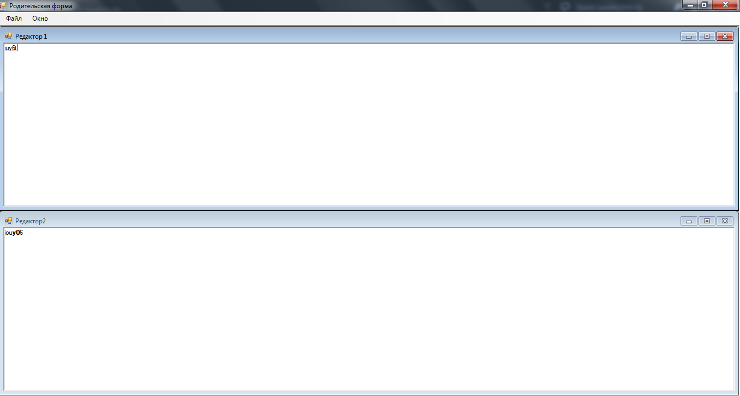

Рисунок 1 – Готовое приложение